Universal Careers Offer: Annual Whole-School Careers Fair

St Mary’s School holds an annual ‘Careers Fair’ for all students in Years 7 – 13. Year groups visit the stallholders for roughly 30 - 40 minutes each throughout the day, to meet local employers, training providers and FE Colleges.
OnTrack+
Look at their OnTrack+ data below. On your table, discuss:
- How could a school use this data to amend their offer of a whole-school Careers Fair?
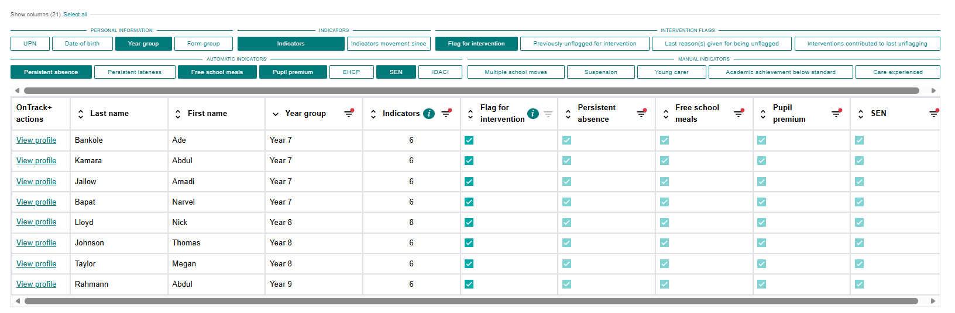
- What adaptations could they make to this activity to target support for this group?

Universal Careers Offer: Apprenticeships Assembly for KS3

Hillfield School is holding an assembly for KS3 students, introducing apprenticeships. A local apprenticeship provider has been asked to come and deliver a 15-minute presentation to share: an introduction to apprenticeships; the apprenticeships they offer; where an apprenticeship can lead.
OnTrack+
Look at their OnTrack+ data below. On your table, discuss:
- How could a school use this data to amend their offer of a KS3 assembly on apprenticeships?
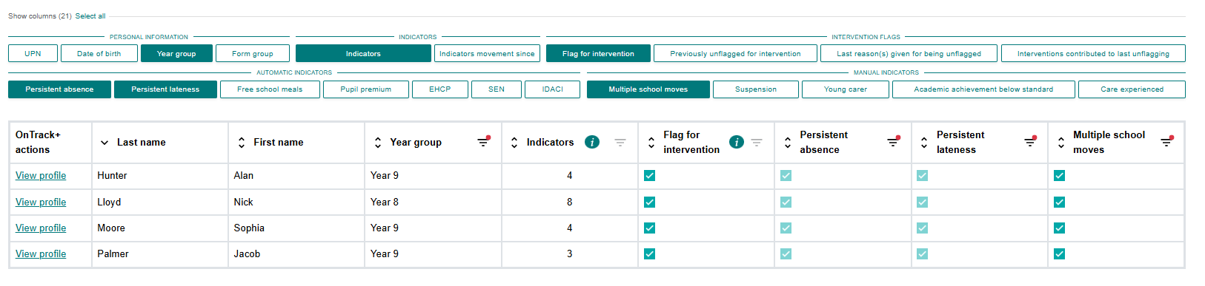
- What adaptations could they make to this activity to target support for this group?

Universal Careers Offer: Year 10 Work Experience Week
Richardson School holds its Work Experience Week as a block for all students in Year 10, during the last week of June. The placement runs across 5 full days. Students are typically responsible for sourcing their placement, but will receive additional support from school staff if required.
OnTrack+
Look at their OnTrack+ data below. On your table, discuss:
- How could a school use this data to amend their offer of a block work experience week for all students in Year 10?
- What adaptations could they make to this activity to target support for this group?
